**Promoted for and on behalf of Cycling Time Trials under its rules and regulations**

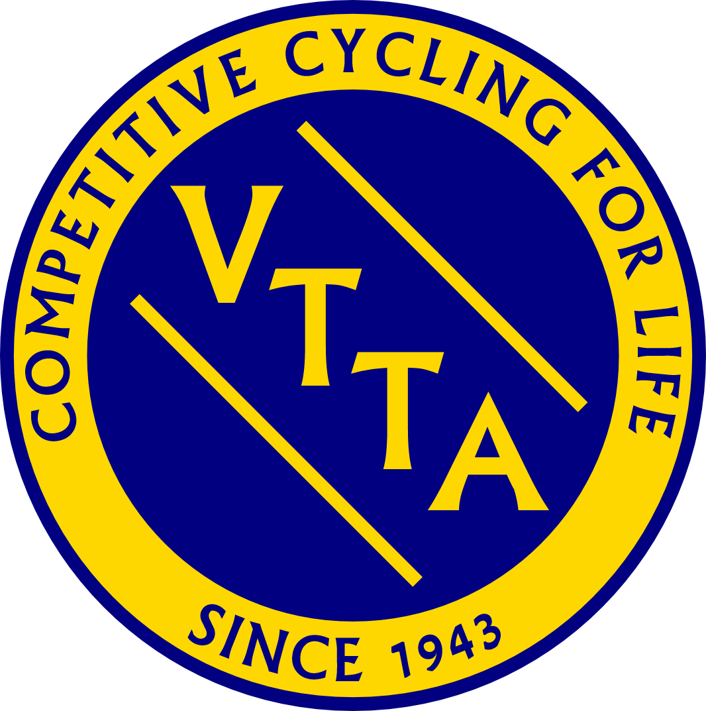

**The RESULTS SHEET for the**

#### East Anglia VTTA 10 mile Individual & Tandem TT

**COURSE E2/10 – SATURDAY 3rd SEPTEMBER 2022**

**Timekeepers: Tim Groves and Wally Groves.**

**Event Secretary: Dominic Whitehead, 4 Dove House Close, Godmanchester,**

**Huntingdon, Cambs, PE29 2DY**

**Home: 01480 380297**

**Mobile: 07504 439362**

**Awards (only VTTA Members are eligible for awards)**

1st Lady Veteran on Std Angela Carpenter +9.17 (£30)

2nd Lady Veteran on Std Denise Hurren +7.45 (£25)

1st Veteran on Std Kevin Tye +8.45 (£30)

2nd Veteran on Std Tim Hood +8.28 (£25)

3rd Veteran on Std Keith Dorling +7.54 (£20)

4th Veteran on Std Gaz Poulson +7.40 (£15)

5th Veteran on Std Mark Jones +7.38 (£10)

£10 prizes 6th-10th equal to Anthony Brown, Chris Dyason, Roger Parker, Simon Smart, Eddie Humphreys and Darran Bennett.

Mens Team on Std Team Bottrill +22.47 (£10 each)

1st Tandem on Std M.Arnold/R.Arnold +6.11 (£30)

1-3rd place in each category can ask for a VTTA medal instead of cash.

**East Anglia Vets only:**

Ron King/Jack Fisher Memorial Shield held jointly for Best Male/Female on Standard

Keith Dorling and Denise Hurren.

Can all prize winners contact me with bank transfer details or request for a medal as soon as possible, please?

My personal thanks go to Tim and Wally Groves for timekeeping, to Keith West for his results service (ably assisted by Richard Moule), to Keith Dorling for signage (both before and after the event- an onerous job cheerfully done), to Dave Nock, Robert Foulke, Matt O’Brien and Stewart Lemanski for pushing riders off, to Tony Cork, Ron Back, Alan Harvey and Gary Boyd for marshalling duties and finally to Renee Friend and her team of lovely ladies from the Isabel Hospice for the catering.



**Proceeds from the catering will be donated to this charity**